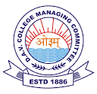
DAV PUBLIC SCHOOL
NTPC- 121004, FARIDABAD (HARYANA)

Date: 24.04.2020

Dear Parents,
We are in receipt of an order from Directorate Secondary Education, dated: 23.04.2020 related to payment of monthly fees. It is under consideration of the School Management.

Meanwhile, your patience and cooperation in this regard will be highly appreciated.

Alka Arora
Principal
DAV PS
NTPC

